Case 5-Asia-China-Liangzhu-Jade Sun Disk-Taotie-Raptors-良渚 - 玉太陽盤 - 猛-ca 3200 BCE

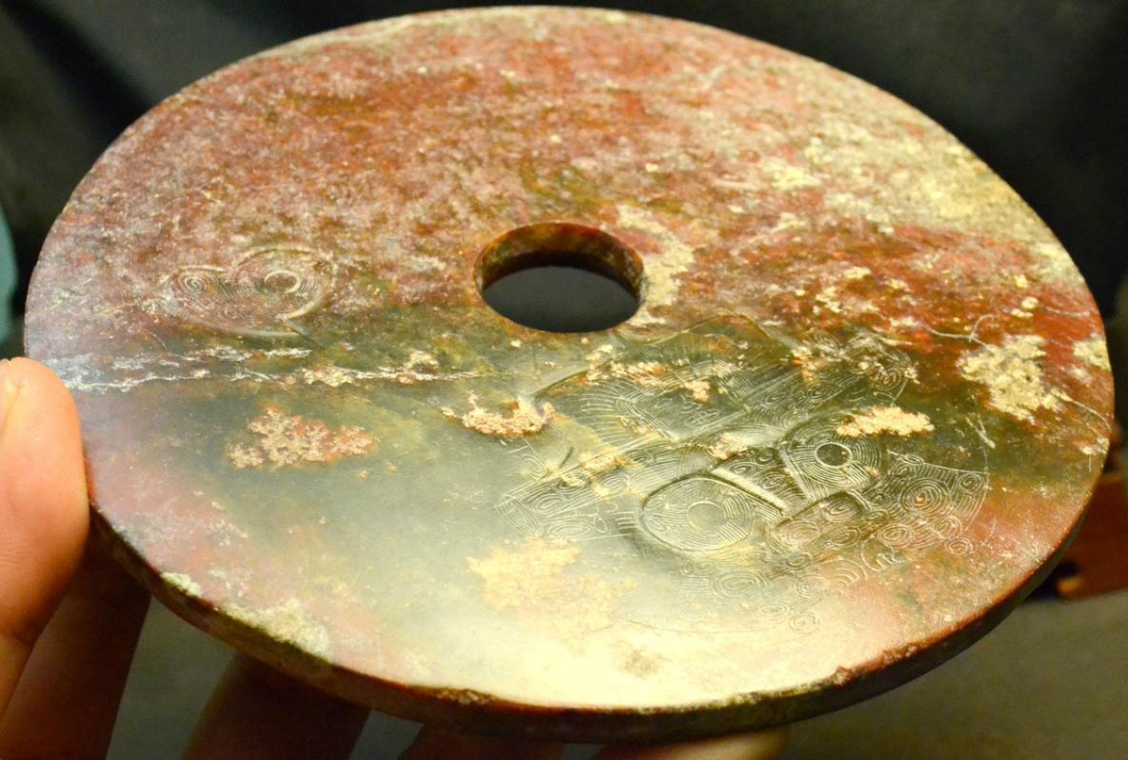

Fig. 1. China- Liangzhu-Jade Sun Disk-Taotie-Raptors-良渚 - 玉太陽盤 - 猛-ca 3200 BCE

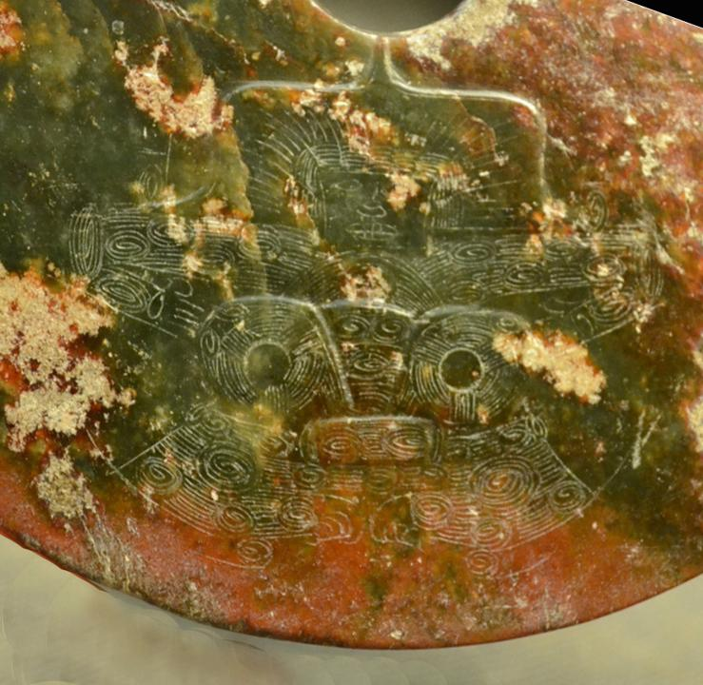

Fig. 2. Detail. Liangzhu-Jade Sun Disk-Taotie-Raptors-良渚 - 玉太陽盤 - 猛-ca 3200 BCE

-- a shaman with a feathered headdress as a crown on top of a so-called “taotie” or symbolic zoomorph on the bottom. On the outer rim of the disk are two images of raptors (with down-curved beaks) that are the spirit helpers of the Shaman in his ascent to the heavens. A very similar design is found on a cong from Zhejiang Province.

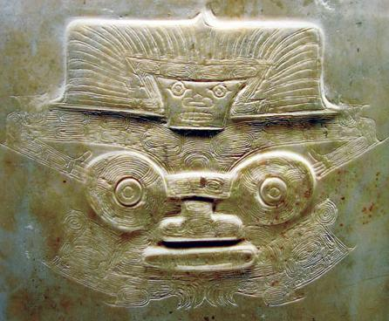

Fig. 3. Shaman's mask with spirit helper headdress found on a cong from tomb M12, Fanshan, Yuhang County, Zhejiang Province, now in the Zhejiang Province Museum (from Zhejian Province Museum. See also Chang et al. 2005. fig. 4.45, p. 112..

The disks that were used in worship in the Neolithic period do not represent spiritual beings in either human or animal shape that were believed to animate nature but were the objects themselves at a time when the concept of the spirit of a thing was not yet separated from the thing itself. In this context this disk is a true effigy, the image of the Sun deity and emblazoned on it in bas relief is the image of a son of the Sun, a ruling ancestor whose property this was as it was used in rituals according honor to the Sun in its various seasonal manifestations. In fact, this jade idol corresponds to the oldest form of Chinese graph designating the Sun disk 太阳盘

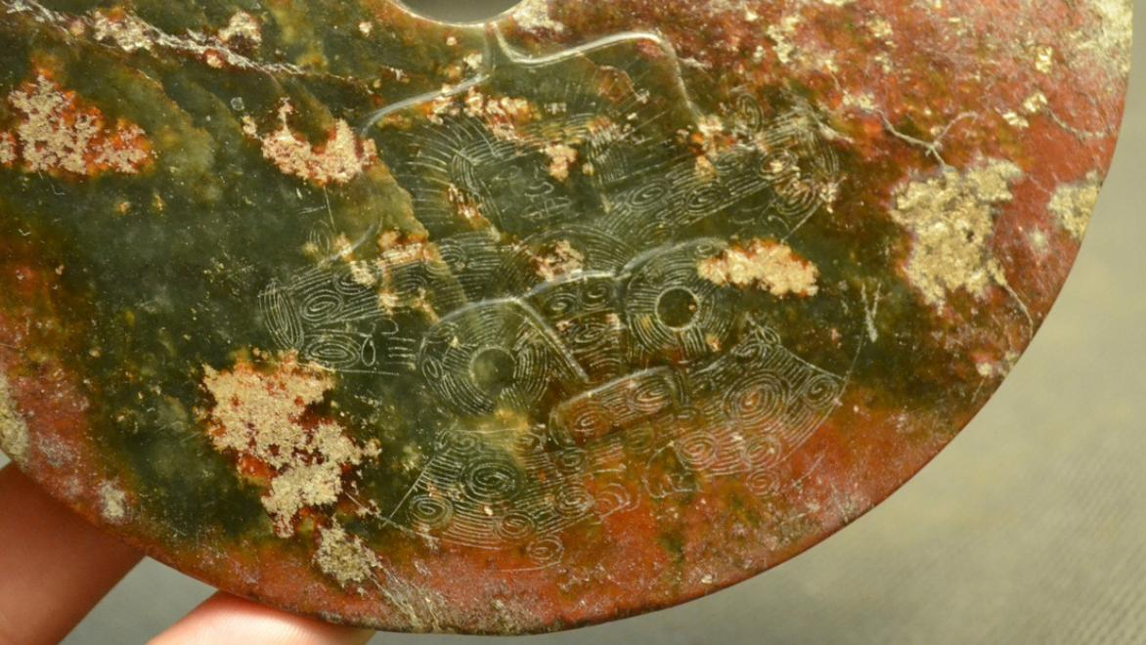

Fig. 4. China- Liangzhu-Jade Sun Disk-Taotie-Raptors-良渚 - 玉太陽盤 - 猛-ca 3200 BCE

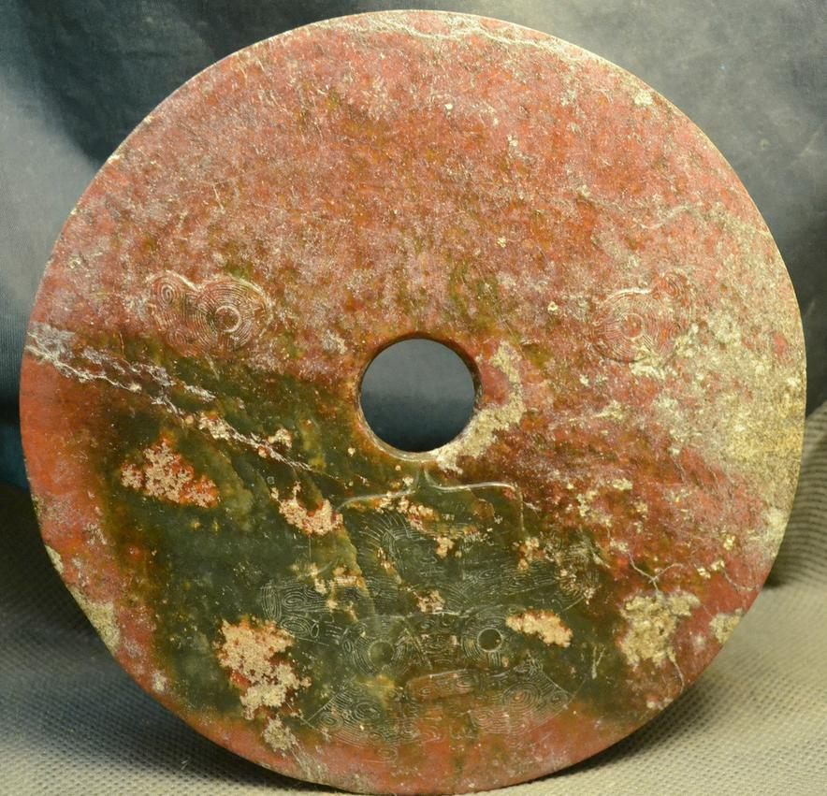

Fig. 5. China- Liangzhu-Jade Sun Disk-Taotie-Raptors-良渚 - 玉太陽盤 - 猛-ca 3200 BCE. Showing the three cartouche-like panels representing an anthropomorphic shamanic mask suggesting the meditation on this disk would induce a shamanic trance.

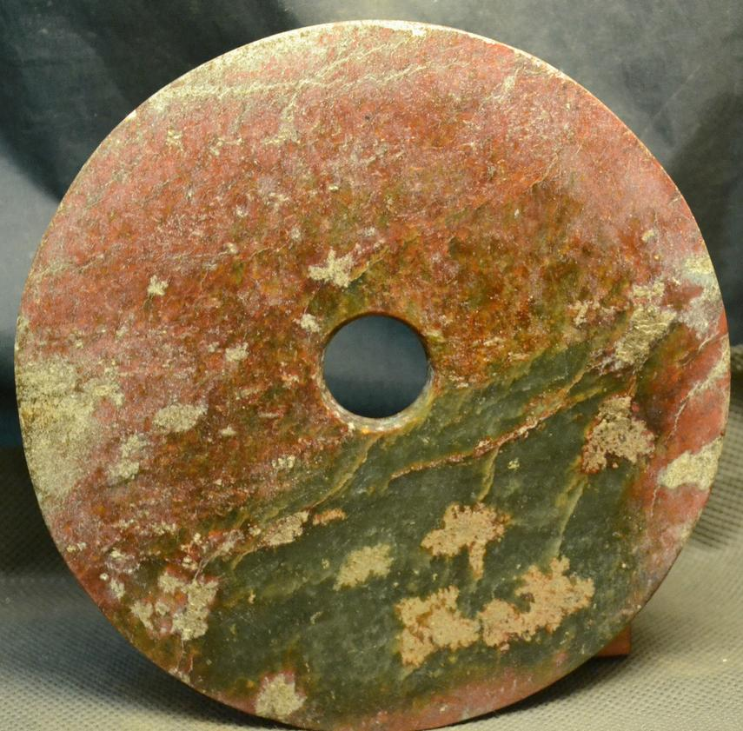

Fig. 6. China- Liangzhu-Jade Sun Disk-Taotie-Raptors-良渚 - 玉太陽盤 - 猛-ca 3200 BCE. The residual green from hematic fluids of the deceased is clearly observable in this photo.

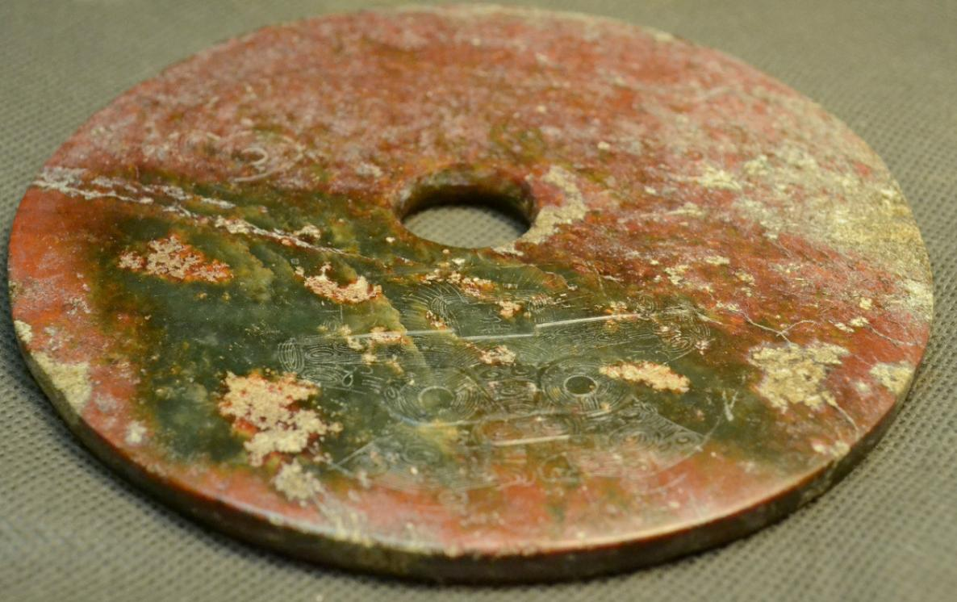

Fig. 7. China- Liangzhu-Jade Sun Disk-Taotie-Raptors-良渚 - 玉太陽盤 - 猛-ca 3200 BCE

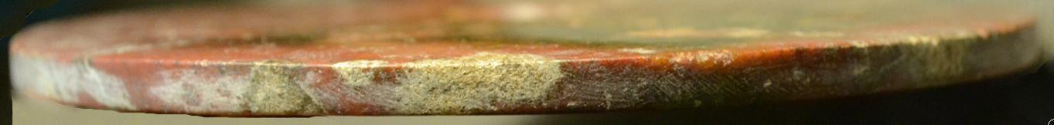

Fig. 8. China- Liangzhu-Jade Sun Disk-Taotie-Raptors-良渚 - 玉太陽盤 - 猛-ca 3200 BCE

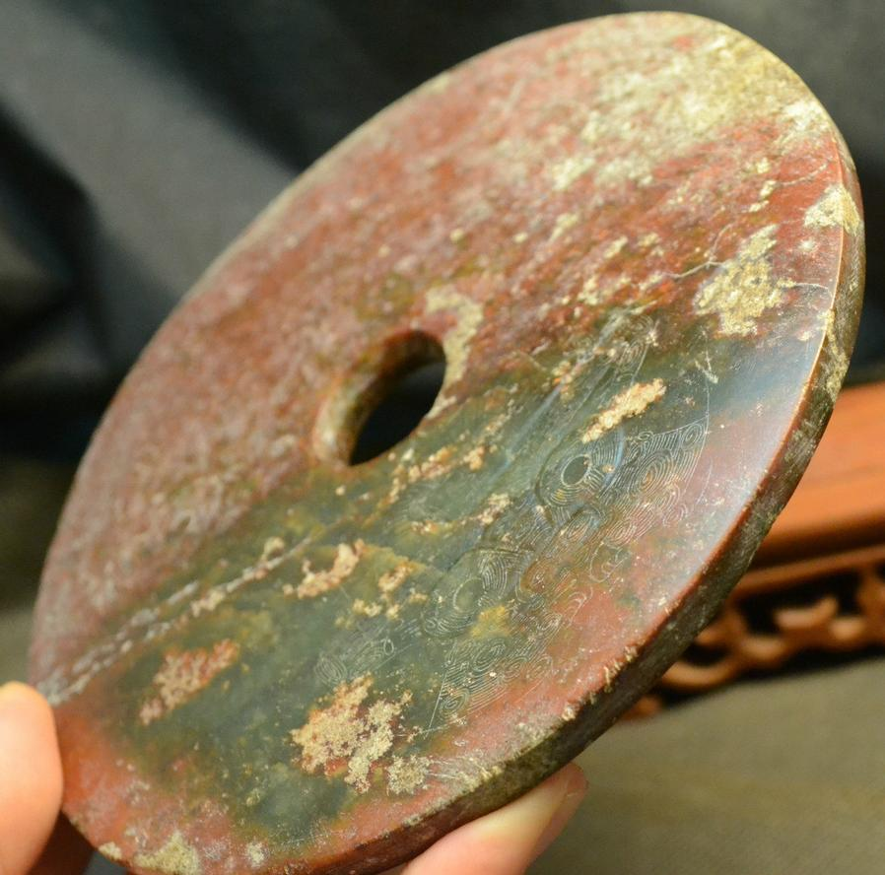

Fig. 9. China- Liangzhu-Jade Sun Disk-Taotie-Raptors-良渚 - 玉太陽盤 - 猛-ca 3200 BCE

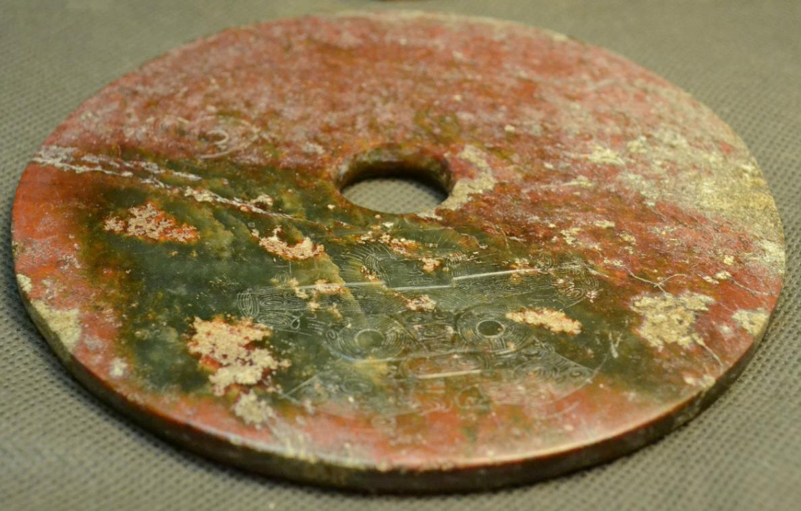

Fig. 10. China- Liangzhu-Jade Sun Disk-Taotie-Raptors-良渚 - 玉太陽盤 - 猛-ca 3200 BCE

**Case no.: 5**

**Accession Number:**

**Formal Label:** Liangzhu-Jade Sun Disk-Taotie-Raptors-良渚 - 玉太陽盤 - 猛-ca 3200 BCE

**Display Description:** This Liangzhu-Jade Sun Disk has images of a Taotie and two Raptors (良渚 - 玉太陽盤 - 猛). The taotie is a bi-laterally symmetrical mask. At the top is an anthropomorphic Master of Animals wearing a feather headdress and leaning with arms and fingers outstretched above a zoomorphic face with two circular eyes and a lozenge –shaped mouth, suggesting meditation on this disk would induce a shamanic trance. This iconography undoubtedly harkens back to a pre-Neolithic period when shamanic imagery was the symbolism of hunter-gatherers and was the imagery that was inscribed on petroglyph panels. Indeed, Hayashi Minao argues that the name of the cong/tsung derived from zhu/chu meaning "master" which we expand to "master of animal powers" (Hayashi 1990:6).

The residual green color of the Bi PI Disc suggests the color symbolism of Heaven. In fact, this Bi PI Disc was probably totally green, and its present reddish color is thought to have been produced by minerals leaching from the decaying body into the nephrite during burial, a process that occurs in the first weeks after interment.

The late Zhou ritual classic, *Zhou Li* p, *Chou Li*  wg(周禮) in the middle of the 2nd century BCE, compiled some three thousand years after the present example was manufactured, stipulated that "jade is used to make the six instruments by which the king worships Heaven and Earth and the four quarters [Spring, Summer, Autumn, Winter]. By the green *bi* (p), *pi* (wg) [round jade disk], heaven is worshipped … " (Biot 1851). According the Zhao Shuang’s Commentary Earth is stationary while the sky revolves in motion, a cosmological concept accepted by the ancients (Chen 1984:95). In this model of a revolving sky the Pole Star is the non-moving pivot. In the *Lushi chunqiu* (v. 2: 659): “The guiding stars and the sky all wander but the pivot of the sky does not move.” Therefore, the central circular hole in this Bi PI Disc symbolizes the unmoving pivot, the pole star, and it is possible that this disc was used to view it through this hole in the night sky.

**LC Classification:** NK5750.2.A1

**Date or Time Horizon:** Liangzhu culture, lower Yangzi River Valley, early Liangzhu Period, ca. 3200 BCE **Geographical Area:** Liangzhu culture, lower Yangzi River Valley

**Map:**

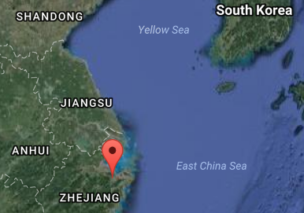

Fig. 11. Location of Liangzhu site. Source: Google Earth

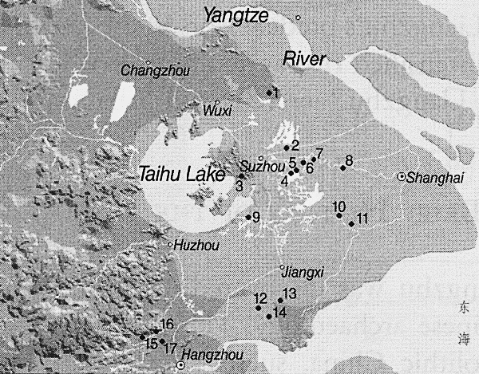

Fig. 12. Detail of Liangzhu site complex surrounding Taihu Lake. After Zhou Ying 2007.

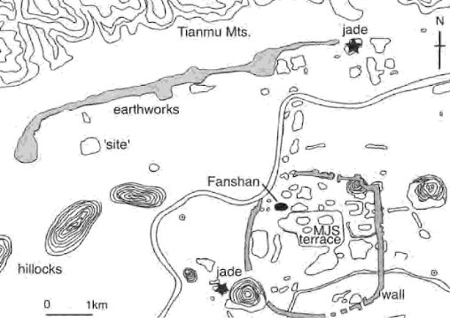

The final phase of the Liangzhu site showing the embankment wall. After Barnes 2009.

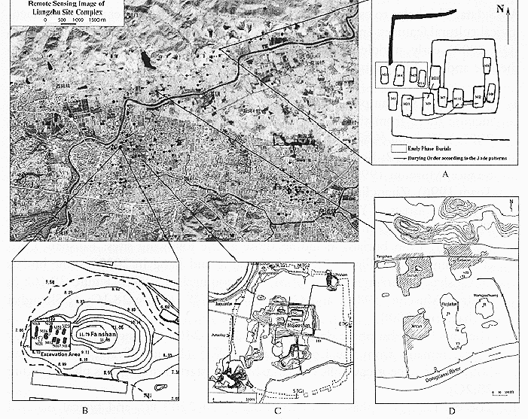

**Fig. 13.** Detail of Liangzhu site proper. After Zhou Ying 2007. B is the Mojiaoshan ritual center of the site.

**GPS coordinates:**

Northeast corner: N 30°24'48", E 120°00'17"

Northwest corner: N 30°24'41", E 119°58'58"

Southeast corner: N 30°23'20", E 120 00'19"

Southwest corner: N 30°22'55", E 119°58'28"

**Cultural Affiliation:** Liangzhu culture, lower Yangzi River Valley, 3300-2250 BCE

**Medium:** Jade

**Cultural Affiliation:** Liangzhu

**Medium:** jade

**Dimensions:** Dia. 15 cm, 1 cm thick

**Weight:**

**Condition: original**

**Provenance:**

**Discussion:**

Liangzhu (3400–2250 BCE) in Yuhang County, Zhejiang, was a highly stratified Neolithic jade city-state in the Yangtze River delta élites controlled a sphere of influence north to Shanxi and south to Guangdong.

DNA recovered from Liangzhu graves shows high frequencies of Haplogroup O1 linking it with modern Austronesians. Hence, Liangzhu is thought to have been the original Austronesian homeland (Freeman Foundation. 2007; Jiao 2007).

The use of jade and other expensive wares (such as silk, lacquerware, and ivory) in grave sites characterized the social symbolism of Liangzhu élites. About 2200 BCE Liangzhu succumbed to a series extreme floods of the Climatic Optimum and this has been identified by intrusions of mud and sand into the cultural layers. After the Climatic Optimum the Liangzhu culture was greatly diminished and finally ceased to exist.

**References:**

Biot, Jean Baptiste. 1851. *Le Tcheou-li: ou, Rites des Tcheou*. Paris: Imprimerie nationale, 1851. 3v.

Chang, K.C., Xu, P. and Lu, L. 2005. *The formation of Chinese civilization: an archaeological perspective*. New Haven: Yale University Press.

Freeman Foundation. 2007. ["Lost Maritime Cultures: China and the Pacific"](https://web.archive.org/web/20150701020443/http:/www.bishopmuseum.org/exhibits/pastexhibits.html). An exhibit at the Bishop Museum, 2007. See Jiao 2007.

Hayashi, Minao. 林巳奈夫. 1991. *Chūgoku kogyoku no kenkyū*. 中國古玉の研究. Tōkyō : Yoshikawa Kōbunkan; 東京 : 吉川弘文館, 1991.



Hayashi, Mineo. 1990. “On the Chinese Neolithic jade Tsung/Cong,” *Artibus Asiae*, 50(1/2):5-22.

Hayashi, Mineo. 1973. *Toyo Gakuho* [Journal of the Research Dept. of the Toyo Bunko] 45:1-57.

Jiao, Tianlong. 2007. *Lost maritime cultures: China and the Pacific.* Honolulu, Hawai'i: Bishop Museum Press.

Jiao, T. “Maritime culture and the prehistory of southeast China.” In Tianlong Jiao*, Lost Maritime Cultures: China and the Pacific*. Honolulu, Hawai'i: Bishop Museum Press, 2007:12-35.

Laufer, Berthold. 1912. *Jade a study in Chinese archaeology and religion*. Field Museum of Natural History, Publication 154, Anthroplogical series, vol. X. Chicago.

Li, Hui; Huang, Ying; Mustavich, Laura F.; Zhang, Fan; Tan, Jing-Ze; Wang, Ling-E; Qian, Ji; Gao, Meng-He; Jin, Li. 2007. "Y chromosomes of prehistoric people along the Yangtze River," Human Genetics **122**: 383–388.

Rolett, B. “Southeast China and the emergence of Austronesian seafaring.” In Jiao, Tianlong. 2007. *Lost maritime cultures: China and the Pacific.* Honolulu, Hawai'i: Bishop Museum Press.

Wu, Li. 2014. "Holocene environmental change and its impacts on human settlement in the Shanghai Area, East China," Catena. **114**: 78–89

Zhang, Chia; Hsiao-Chun, Hung. 2008. "The Neolithic of Southern China–Origin, Development, and Dispersal," Asian Perspectives. **47**:2, 309–310.

|  |
| --- |
| Zhou Ying. 2007. 东方文明的曙光: 良渚遗址与良渚文化 = **Dong fang wen ming de shu guang : Liang zhu yi zhi yu liang zhu wen hua =** *The Dawn of the Oriental Civilization: Liangzhu site and Liangzhu culture*. Beijing: China Intercontinental Press. |